“Do you realize that Jesus is there in the tabernacle expressly for you- for you alone? He burns with the desire to come into your heart…”
-St. Therese of Lisieux
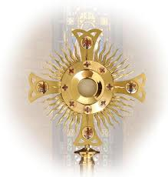
Please join us for our first Family Holy Hour of the year, on Friday, October 21st from 7:00 p.m. -8:00 p.m. at our beautiful chapel here at East Lake Academy. Invite your family and friends! All are welcome! What a great way to start our school year adoring Christ and singing praises to Him!

