A CLC Newspaper provided by a generous grant from the Woodstock Independent |  | 9/29/16
MRS. BIASCO’S AND MRS. BEATTIE’S CLASSES ARE OUTTA THIS WORLD!
Mrs. Beattie and Mrs. Biasco were delighted to see their students on task for a successful mission to learn about careers and opportunities in the STEM fields. She said: “I like bringing students to the Challenger Learning Center because it is a great place to learn about NASA’s history and all about space. I enjoy visiting their Mission Control Center and spending time on the Space Shuttle.” | 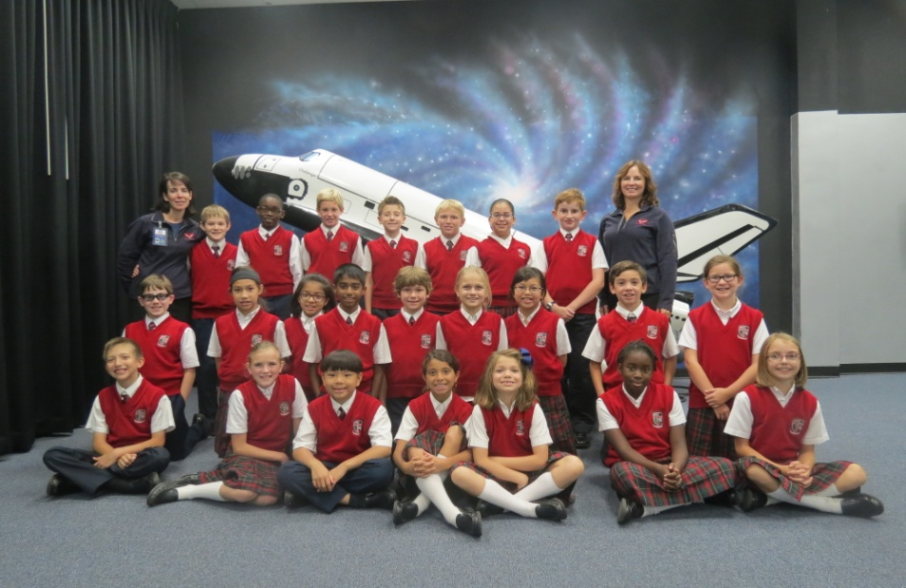 |  | Conner, a student in Mrs. Beattie’s class, loved working on the ISO 2 Team. He said: “I like ISO 2 because you are helping the team in a life or death situation.” Ella liked working on the MED team. She said: “I like it because you can research stuff.” Konner liked working as the Communicator. He said: “I like being the Communicator because I get to talk to everyone.”
 | Today, Mrs. Beattie’s and Mrs. Biasco’s 4th and 5th grade classes from East Lake Academy in Lake Forest, IL rendezvoused with a comet! The mission was a complete success as students performed hands-on science experiments and team building activities in order to conclude their mission successfully. Students had the opportunity to participate on one of eight teams including Communication, Data, Navigation, Medical, Remote, Life Support, Isolation and Probe. They moved through both the Spacecraft and Mission Control as they attempted to launch their probe through the tail of the comet. They had to work as a team in order for their mission to be successful. The entire class said the experience was challenging and fun; a once in a life opportunity!
Please join us for Club Challenger. See our website for details.
www.challengerillinois.org
815-338-7722
Visit www.challengerillinois.org for Family Science Night information | 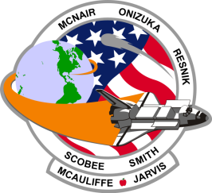  Our Challenger Learning Center is in the forefront of STEM education, integrating science, technology, engineering and math into a real world simulation. We are one of 43 active Challenger programs in the world! Taking students beyond the classroom and providing them with an unforgettable experience will impact their lives forever. We change the way students learn and teachers teach by using inquiry-based learning within a robust curriculum to encourage students to inspire, explore and learn. |  | 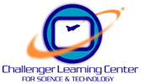  Rebecca Dolmon  Lead Flight Director  222 Church Street  Woodstock, IL 60098  rdolmon@aurora.edu
Thank you to the Challenger Center’s founding board members:
June Scobee Rodgers, Charles Resnik, Marcia Jarvis-Tinsley, The Honorable Steven McAuliffe, Cheryl McNair, Lorna Onizuka, and Jane Smith Wolcott

